
Psychomotor Vigilance Task Instructions

The goal of this task is to respond as quickly as possible when a red dot appears on the screen. There are 85 dot presentations in total and this task should take approximately 10 minutes to complete.

Task protocol

After a 5 second countdown, a white fixation cross will appear in the centre of the screen. Please focus on this cross for the duration of the task. The countdown will not appear again.

Whilst you are focusing on the cross a red dot will appear in the centre of the screen. You will have a very short time to press the ‘spacebar’ with your dominant hand once the red dot comes up. If you are fast enough, the dot will turn white indicating that you responded quickly enough. A fixation cross will then appear once again, and the process will repeat. See diagram below:
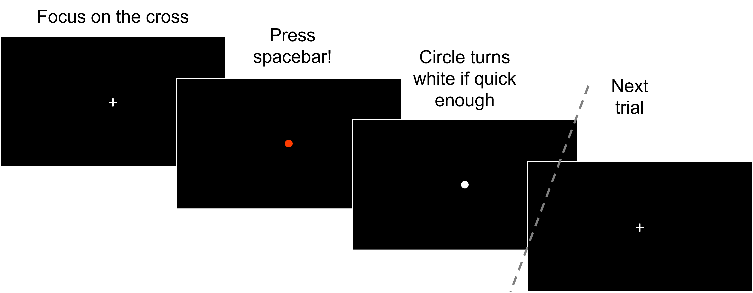

Try to be as quick as possible and press the spacebar for all red dots

There is one continuous block with 85 dot presentations. Sometimes there will be a long break between dots and sometimes a string of dots will be presented close together, so try and maintain your attention throughout the whole task.

If you have any questions, please ask the experimenter now

